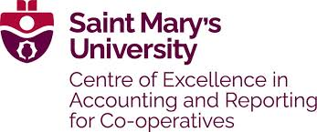
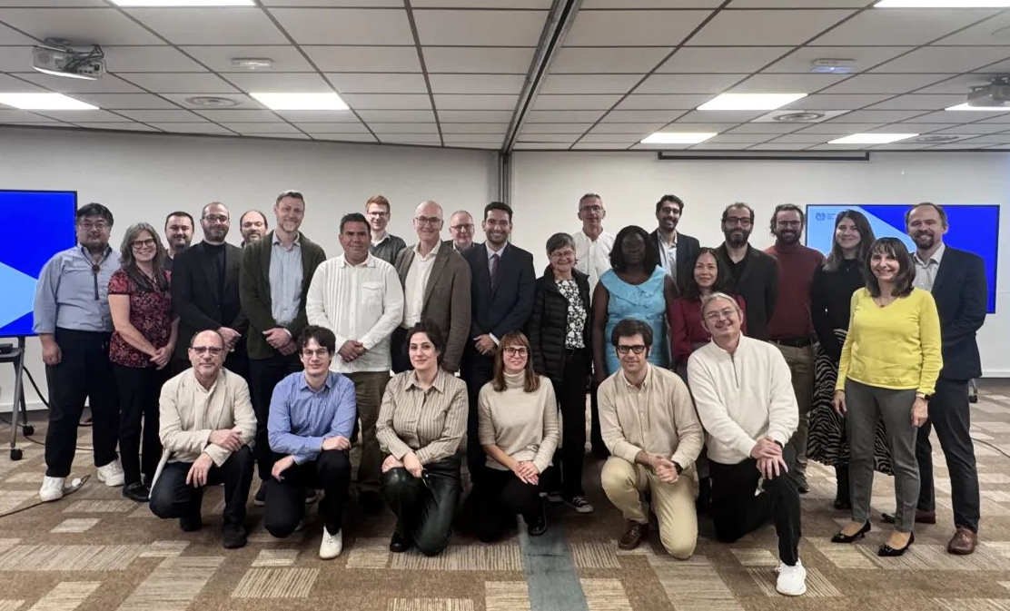
CEARC Newsletter Jan 2026

Making Co-ops Count: Inside the Technical Working Group on Measuring Economic Contribution of Co-operatives
Fiona Duguid

Not many people would describe two days in a room with statisticians, accountants and researchers as energizing, but that is exactly what the recent Technical Working Group (TWG) – Measuring Economic Contribution of Co-operatives “Deep Dive” in Bordeaux turned out to be for Fiona.
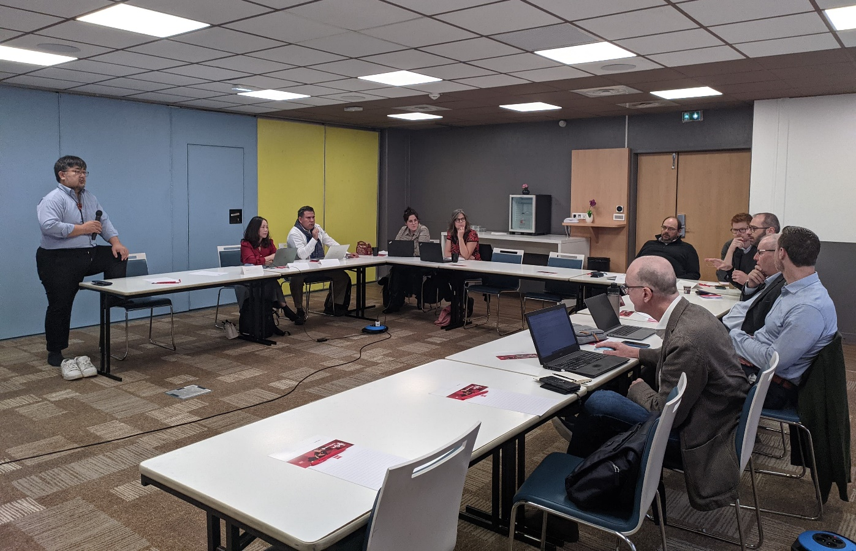
The TWG-MECC is tasked with developing robust methods to measure the economic contribution of co‑operatives, building on the ILO Guidelines Concerning Statistics of Cooperatives adopted in 2018. The meeting in November focused on strengthening a shared understanding of key statistical concepts, building consensus on priority issues, and agreeing on a concrete workplan, including next steps to review and confirm a common set of indicators. Participants wrestled with very real challenges: compiling consistent data across jurisdictions, aligning definitions, and finding ways to capture not only economic output but also social, environmental and community impacts that traditional statistics often miss.

As a researcher from Canada, it was an excellent opportunity to share experience from recent economic impact research on co‑operatives and mutuals and to situate that work in a global context. On a personal level, it was inspiring to meet others who share a genuine passion for “co‑op stats” and to see how technical work can advance the broader co‑operative movement. The next step for Fiona will be to apply the emerging co-operative stats framework in the upcoming Canadian research with Co‑operatives and Mutuals Canada on economic contribution and impact of co-operatives and mutuals in Canada—an important chance to pilot the indicators and help position Canada at the leading edge of co‑operative measurement and reporting of contribution and impact.

