Kinetic Simulation of Electrochemical Degradation
-- battery fade and alloy corrosion
Penghao Xiao
Department of Physics and Atmospheric Science, Dalhousie University, Halifax, NS, Canada

Materials in electrochemical environments experience accelerated degradation due to the inherently non-equilibrium nature of these systems. In functional materials such as Li-ion battery electrodes, degradation leads to capacity loss over cycles, while in structural materials like alloys, aqueous corrosion progressively weakens mechanical properties. Both processes have significant economic and technological implications.

In this talk, I will present our recent progress in simulating long-time-scale kinetics of materials degradation under electrochemical conditions. We introduce a lattice-based atomistic simulation framework from first principles that integrates multiple kinetic processes without empirical parameters. This approach enables us to uncover the evolving rate-limiting steps without preconceived assumptions. By reaching time scales of milliseconds and beyond, our simulations allow direct comparison with experiments. I will discuss two key examples:
- High-Ni layered oxide cathodes – These materials offer high energy density but suffer from significant capacity loss during cycling, a phenomenon that remains poorly understood, limiting further improvements. Using LiNiO₂ as a model system, our simulations successfully reproduce both the first-cycle irreversible capacity loss at the end of discharge and the sluggish kinetics of the H2-H3 phase transition at the end of charge. After repeated cycling, we find that a surface-densified phase forms, suppressing H3 phase nucleation and severely hindering delithiation when Li content falls below 25%, while lithiation remains unaffected. These findings are in good agreement with recent experimental observations.
- Aqueous corrosion of NiCr alloys – To simulate surface oxide evolution, we introduced a moving boundary condition, allowing us to track oxide thickness variation alongside composition changes. The predicted oxide behavior as a function of voltage, temperature, and pH aligns well with experimental characterizations. Furthermore, we uncover a new oxide growth mechanism driven by dissolution and reprecipitation in certain voltage range, providing fresh insights into surface structure reconstruction under electrochemical conditions.

Short Bio:
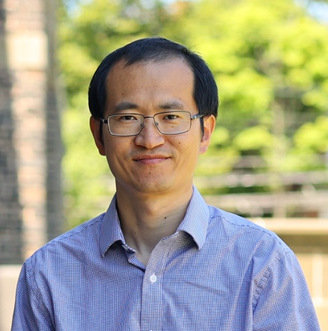
Dr. Penghao Xiao is an assistant professor in the Department of Physics and Atmospheric Science at Dalhousie University in Halifax, Nova Scotia, Canada. Dr. Xiao obtained his Ph.D. from the University of Texas at Austin in 2014. He did his postdoc trainings at Lawrence Berkeley National Laboratory and then at Lawrence Livermore National Laboratory in California before joining Dalhousie University in 2021. His research focuses on the computational study of materials, with a particular interest in the atomistic processes that are critical to materials’ synthesis, performance, and degradation. His group adopts state-of-the-art computational techniques, as well as develops new simulation methods, to study ion diffusion, phase transition, and surface reaction in battery materials and structural alloys under experimentally relevant conditions.

